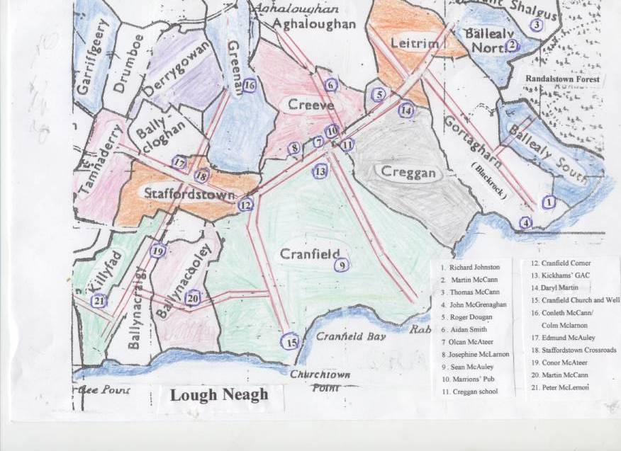
1. Richard Johnston
2. Martin McCann
3 . Thomas McCann
4. John McGrenaghan
5 . Roger Dougan
6 . Aidan Smith
7 Olcan McAteer
8 .Josephine McLarnon
9 . Sean McAuley
10. Marrions’ Pub
11. Creggan School
12. Cranfield Corner
13. Kickhams’ GAC
14. Daryl Martin
15. Cranfield Church
and Well
16. Conleth McCann/
Colm Mclarnon
17. Edmund McAuley
18. Staffordstown
Crossroads
19. Conor McAteer
20. Martin McCann
21. Peter McLernon

