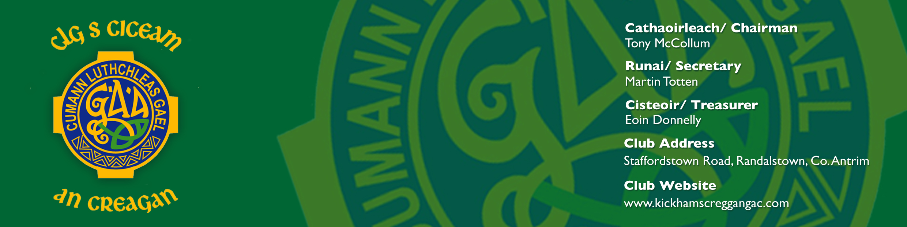
14th December 2011
A Chara,

Thomas Devlin Motors Sponsored
Ulster U21 Club Football Tournament
2011
On behalf of Kickhams Creggan GAC, may I congratulate your Club on winning your County U21 Football Championship or League, and I have pleasure in formally inviting you to compete in the above competition. Prior to this, I cordially invite you to attend the draw for the competition.
The draw for this year’s competition will take place on:
Date: Thursday 29th December 2011
Location: Kickhams Creggan GAC,
134 Staffordstown Road,
Randalstown,
Co. Antrim
BT41 3LH
Time: 8:00pm SHARP
Attendees: Club representatives’ including team captain, a number of players, team jersey and your U21 Championship/League Cup.

This event will be attended by members of the press.

About the Competition
- 3rd Annual Ulster U21 Club Football Tournament
- Prestigious Cup – Paddy McLarnon Memorial Cup
- Players medals
- Man of the Match Awards
- Panel and Mentor refreshments
- All matches will be played at Kickhams Creggan GAC
- The preliminary round match is provisionally scheduled for the 22nd January and the Final is provisionally scheduled for the 19th February. These dates have been approved by Ulster Council and games will be played on Saturdays and Sundays.

Player Age Rule
Ulster Council demands that we furnish them with a full list of your playing panel and their dates of birth before the competition commences. We therefore ask for your co-operation in supplying this information as soon as possible. You will note that while this competition will be played in January and February of 2012, it is for the respective 2011 U21 Club Football Champions.

Club Details
In order to help with publicity for the competition and the printing of programmes for each match, we would be grateful if you could complete Sections 1 & 2 of this document which will supply us with details concerning your Club, your U21 Players panel and their Mentors. I would ask that these Sections are completed in either Block Capitals or preferably emailed.
In addition please note the following:
- The competition is 15 aside and subject to all GAA Official Guide Rules
- In the event of a draw at the end of normal time, extra time of 10 minutes each way, will be played.
- In the event of a jersey clash both teams will change. Clubs will be given advanced notice of this.
- For the duration of the competition we use team numbers. All players MUST play in the numbers as given in the Player Registration (Section 2). Once a player has been given his number, they cannot change.
- Team lists are to contain no more than 30 players.
- We publish a programme for each of the matches and will therefore require details of your actual team and substitutes on the Monday prior to each match.
- Clubs are reminded to advise their respective County Secretary of their intention to participate in this competition

If your Club or Sponsor wishes to place adverts in the programme then please contact Eunan McAteer, Competitions Officer (Contact details provided).

Food/Refreshments
After each match food will be supplied for up to 30 players and mentors.
Once again congratulations on your success this year and I look forward to meeting you at Kickhams Creggan GAC in the near future, for what I’m sure will be an intriguing competition.
If at any stage you have any questions on any matter, I can be contacted on the details below.
Alternatively, your first point of contact on any match day issues should be with Gerard McLarnon who is our Club Liaison Officer. Gerard’s number is 07786395161.

Is mise, le meas
Eunan McAteer, Competitions Officer
44 Cargin Road,
Toomebridge,
Co. Antrim,
BT44 3NU
Tel: +447895903431
+353873791690
Email: lmiemr@googlemail.com

Thomas Devlin Motors Sponsored
Ulster U21 Club Football Tournament 2011
Section 1
Club Registration Form
Club Name
Statement of Invitation Acceptance | We are pleased to accept the invitation to participate in The Thomas Devlin Motors, Ulster U21 Club Football Tournament 2011
Official Club Colours
Team Mentors
Recent Club Achievements

Club/Team Contact Details
Name
Address
Contact Number
Email

Thomas Devlin Motors Sponsored
Ulster U21 Club Football Tournament 2011
Section 2
Player Registration Form
FOGRA: All player details MUST be complete and returned prior to start of competition.
Squad No. | Player’s Name | Position | Date of Birth
1
2
3
4
5
6
7
8
9
10
11
12
13
14
15
16
17
18
19
20
21
22
23
24
25
26
27
28
29
30

Please complete and return Sections 1 & 2 ASAP to Eunan McAteer, Competitions Officer on any of the supplied contact details.

